The ZMPT101B AC Voltage Sensor Module

Interface ZMPT101B AC Voltage Sensor with Arduino
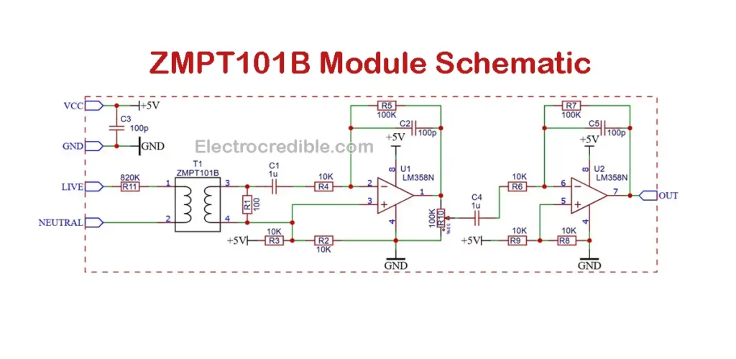
The LM358 IC features dual opamps in a single IC. In the ZMPT101B module, both the opamps work in inverting amplifier configuration with a gain of 10(set by the 100K and 10K resistors R4, R5, R6, R7). The first opamp inverts the signal by 180 degrees and passes it to the second one, which again adds a phase shift of 180 degrees, thereby restoring the phase of the original signal. Moreover, using two opamps instead of one improves stability and bandwidth.
Both the opamps are biased at VCC/2 so that the waveform stays centered around the mid-point of Arduino’s operating voltage. A trimpot (R10) onboard the ZMPT101B module lets us adjust the gain or amplitude of the waveform obtained via the OUT pin.

ZMPT101B Pinout
The ZMPT101B module consists of 4 pins for interfacing with a microcontroller and a screw terminal block for connecting AC wires. Two of the pins are Ground pins (GND) and any one of them can be used. The module works with a 5 Volts supply between the VCC and GND pins. The maximum AC voltage to the input terminals should be limited to ±250 V.
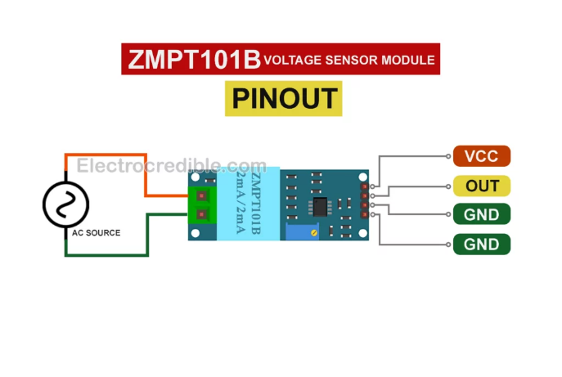
The sensor module outputs a voltage equal to VCC/2 when no input AC is applied. In the presence of AC at the terminal block, voltage at its OUT pin varies proportional to the AC voltage supplied.

